

Draw It or Lose It

# **CS 230 Project Software Design Template**

Version 3.0

## Table of Contents

**CS 230 Project Software Design Template**1

**Table of Contents**2

**Document Revision History**2

**Executive Summary**3

**Design Constraints**3

**System Architecture View**3

**Domain Model**3

**Evaluation**3

**Recommendations**5

## Document Revision History

| Version | Date | Author | Comments |
| --- | --- | --- | --- |
| 1.0 | 9/20/20 | Ryan Cooper | Initial Gaming Room Application Design |
| 2.0 | 10/7/20 | Ryan Cooper | Evaluation of the Operating Platforms |
| 3.0 | 10/18/20 | Ryan Cooper | Recommendation |

**Executive Summary**

The Gaming Room is wanting to develop a web-based gaming application that can be used across different platforms. They created a game called “Draw It or Lose It”, however it is only available on Androids and they want it to be available across all platforms. The objective of the game is to work with your team to guess what the rendering image is. The image will be fully rendered in 30 seconds, and if the team does not guess what it is, the opposing teams will receive 15 seconds to do so.

## Design Constraints

* Must be able to run on multiple platforms
* The game needs to have the ability to have one or more teams playing
* Multiple people are needed to play this game
* Games and team names must differ so that the users can check to see if their name has already been chosen as a team name.

## System Architecture View

*Please note: There is nothing required here for these projects, but this section serves as a reminder that describing the system and subsystem architecture present in the application, including physical components or tiers, may be required for other projects. A logical topology of the communication and storage aspects is also necessary to understand the overall architecture and should be provided.*

## Domain Model

In the Gaming Room UML Diagram below, we can see object-oriented principles being demonstrated. Entity is the parent class to Game, Team, and Player. Thus the “children”, Game, Team, and Player show inheritance from the Entity class. Aggregation is best demonstrated in between GameService having Game and Team having Players. This is when an object from one class uses another object from a different class. Lastly, we can see that in the Entity class, there are private variables and therefore Entity is encapsulating these variables. In other words, Encapsulation is when a class “protects” or limits its variables to public methods outside of the class.

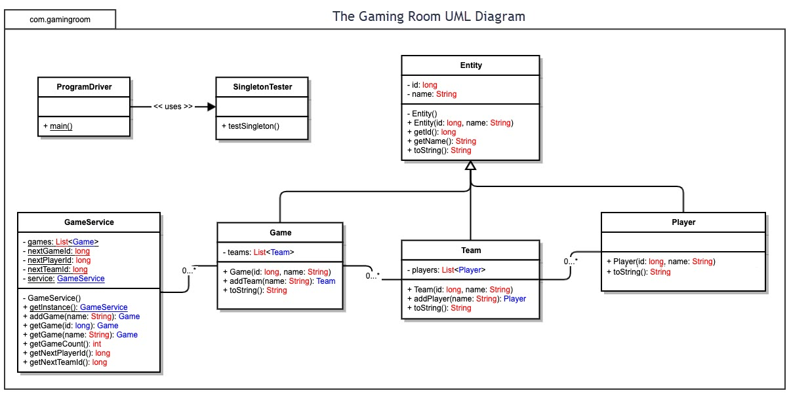

## Evaluation

Please review table below. References can be found on the last page of this report.

| **Development Requirements** | **Mac** | **Linux** | **Windows** | **Mobile Devices** |
| --- | --- | --- | --- | --- |
| **Server Side** | The MacOS can be configured easily by IT professionals. It also has its AppleScript which is a language that can be used to automate mundane tasks. There are no licensing fees for the OS itself, but additional expenses may be incurred if a program does not work with the MacOS. Windows may have to be purchased separately if need be. Server based deployment for businesses is available for MacOS. | More complex which can be good, but can also make certain tasks more difficult, such as using an application that is not cloud based. Has a command shell to make for easier configuration of the system. Although there are no licensing fees associated with Linux itself, businesses will often use platforms that run on Linux, such as Red Hat, which the cost for platforms such as these can run anywhere from $99 – 1,299, dependent on the subscription type. | Most friendly when it comes to compatibility with other software. Being that it has an approximate 83% market share (Kumar, Singh, & Bargotra, 2019), it makes it one of the largest targets for black-hat hackers to exploit. Windows makes it easy for the network admin to add new users and control what users are authorized to do. There is a $20 licensing fee per user, but this can go lower, dependent on the number of users. The fee includes many resources including the full Microsoft Office Suite. One terabyte of cloud storage is also included. | Challenging for application developers because the specs will need to vary from OS to OS (i.e. iOS & Android). |
| **Client Side** | Geared towards user experience and customization based on personal preferences. MacOS comes loaded with applications, especially geared towards the arts (i.e. video editing, music editing, etc.) The layout of MacOS has not changed much since the creation. Therefore, users will not be needing to relearn the OS after a large update every few years.  The client will endure a 30% commission fee for the purchases made through the Apple App Store. (Borck, Caminade, & Wartburg, 2020) | Not user friendly and will require a lot of training. Frustration can arise when other applications are not compatible. Troubleshooting compatibility issues will be an inevitable part of using Linux. However, it is also the least expensive option. | Many users are already acquainted with Windows OS. Windows has always been tailored to being a leader for video gaming environments. However, Macs will still come prepackaged with better video editing software. Windows and Macs are similar when it comes to pricing options. The client will, likewise, endure a 30% commission fee. (Borck, Caminade, & Wartburg, 2020) | Dependent on the technology knowledge gap that the user may or may not have, will determine how easily and quickly they are able to navigate the OS. Preferred by many users because of how compact and powerful modern-day phones are. The client will endure the following breakdown for commission fees:   * Google Play Store: 30% * Amazon Appstore: 30% * Samsung Galaxy Store: 30%, but possible reduction based on downloads * Apple App Store: 30%   (Borck, Caminade, & Wartburg, 2020) |
| **Development Tools** | MacOS can handle all the common languages such as: HTML, Python, JavaScript, and more. There are also extensions that be used to support other languages and/or library packages. | Like other OS, Linux can read the common languages such as Python, C#, CPP. Will also be able to run versions of IDEs such as Visual studio. | Same capabilities as Linux, but easier to work with. Likewise, can read many of the common languages and can run many different developer tools such as Eclipse. | Can interpret many common languages. Many applications are made with C#, Java and/or C/C++ |

## Recommendations

**I misread the instructions in project one and completed this section already, but I will be redoing/editing it.**

Analyze the characteristics of and techniques specific to various systems architectures and make a recommendation to The Gaming Room. Specifically, address the following:

1. **Operating Platform**: I would recommend that The Gaming Room goes with Windows for their operating platform. Not only is Windows compatible with nearly all types of software, their computers are also ready to be used right out of the box. All of computers relate to an active directory that can be configured from corporate. This will be a time saver as they intend to grow and expand their business.
2. **Operating Systems Architectures**: Windows architecture is designed for superior performance. Windows NT (New Technology) has a layered system of modules which consist of: Hardware-Abstraction Layer, Kernel, and the Executive. This allows it to have two different modes: User Mode and Kernel Mode. In short, User Mode is where applications are being ran and Kernel Mode is how the applications can access the hardware. Many of the core applications that will be used are already windows-based applications. Win32 is the Windows application programming interface (API) will allow for the developers to take advantage of all the capabilities and features that each API category has. An API category that will be beneficial for creating “Draw It or Lose It” is the graphics and multimedia API.
3. **Storage Management**: Windows does a nice job at organization on its system when it comes to the storage of data. There is an API specifically for data access and storage. Within here, Windows OS has a wide range for how it deals with management storage, from external drives such as the One Drive which is stored in the cloud or simple storage methods such as single-disk desktops. The GUI makes it easy to manage and sift through all the data. There are also built in functions, such as Storage Sense, that lets Windows automatically pick out old files that have not been used, emptying the recycle bin & downloads folder, to name a few of the ways Windows can help free-up storage.
4. **Memory Management**: Windows manages virtual and physical memory in “pages”. The Memory Management Unit will use page table data structures that will dedicate different amounts of space for different processes. Each process on the 32-bit Windows OS will be allocated its own virtual address space that can hold up to 4gb of memory. The virtual memory will process the game code and then can be quickly exchanged between the physical memory and RAM. The virtual memory is what will allow us to run large game files while keeping the program running smoothly.
5. **Distributed Systems and Networks**: A distributed system is when a communication network joins a group of processors. The communication network server can be thought of as the game server while the group of processors connected to this server are the users. The server that the game is hosted on allows for the resource files to be distributed so that the various users can be playing separate games at the same time. This can also allow for the developers to access the different files on the servers remotely, without interference to others. Anticipating that there will be a lot of people playing the Draw It or Lose It game, a distributed system can break up the connection workload by having it be mapped so that different processors are handling X amount of connections.
6. **Security**: All computers that run on a Windows’ OS come preinstalled with security features such as malware protection, firewall & network protection, and device security features such as facial recognition software. The corporate computers that will be given out can also be accessed remotely to erase, shut down, and lock any computer if it were to be stolen or misplaced. Most of these Window OS computers will be accessing data from within Microsoft’s cloud services. All this data will be encrypted, whether it be stationary on the computer or being transferred from the server. The Federal Information Processing Standards is one of the many components of the Microsoft Security Policy. Using this standard as an example, Microsoft uses cryptographic resources, that are already included within the Windows OS, to run certificates and authentication methods. Microsoft’s cloud platform is Azure, and it includes a multitude of encryption methods for protecting the various amounts of data types, both in transit and not.

# **References for Evaluation**

Borck, J., Caminade, J., & Wartburg, M. (2020). *Apple's App Store and Other Digital Market Places.* Analysis Group.

Gewirtz, D. (2019, April 8). *Windows, Mac, or Linux? We compare the pros and cons of these computing platforms.* Retrieved from ZDNet: https://www.zdnet.com/article/windows-mac-or-linux-we-compare-the-pros-and-cons-of-these-computing-platforms/

Kakar, A. K. (2015). Why do users speak more positively about Mac OS X but are more loyal to Windows 7? *Computers in Human Behavior*, 166-173.

Kumar, D., Singh, M., & Bargotra, R. (2019). Operating Systems: Pros & Cons. *JETIR*, Issue 3, Volume 6.

**References for Recommendation**

Fortuna, A. (2019, March 13). Some thoughts about Windows Memory Management | Andrea Fortuna. Retrieved from Some Thoughts about Windows Memory Management website: https://www.andreafortuna.org/2019/03/13/some-thoughts-about-windows-memory-management/

Microsoft. (2010, March 25). Graphics and Multimedia (Windows). Retrieved from docs.microsoft.com website: https://docs.microsoft.com/en-us/previous-versions//aa969176(v=vs.85)

Microsoft. (2017, April 20). User mode and kernel mode - Windows drivers. Retrieved from Microsoft.com website: https://docs.microsoft.com/en-us/windows-hardware/drivers/gettingstarted/user-mode-and-kernel-mode

Microsoft. (2020, May 12). Encryption in the Microsoft Cloud - Microsoft 365 Compliance. Retrieved October 19, 2020, from docs.microsoft.com website: https://docs.microsoft.com/en-us/microsoft-365/compliance/office-365-encryption-in-the-microsoft-cloud-overview?view=o365-worldwide#:~:text=Microsoft%20provides%20service%2Dside%20technologies

Silberschatz, A., Galvin, P. B., & Gagne, G. (2010). *Operating system concepts* (8th ed.). Retrieved from http://www.uobabylon.edu.iq/download/M.S%202013-2014/Operating_System_Concepts,_8th_Edition%5BA4%5D.pdf